Assignment – 1

Name – Mayank Dhankar

Roll no. - 038

Class – BCA AI ML (IB)

Group - 1

Question 1) Create a simple HTML page using basic tags.

Input-

<html>

<head>

<title> Student Information </title>

</head>

<body>

<h4> Basic Tags</h4>

</body>

</html>

Output-

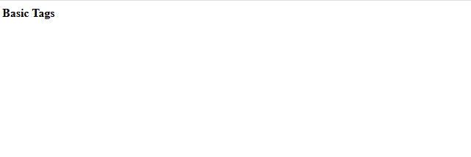

Question 2) Create a web page that display your name to the screen.

Input-

<html>

<head>

<title> Student Information </title>

</head>

<body>

<h4> Student Name – Mayank Dhankar </h4>

</body>

</html>

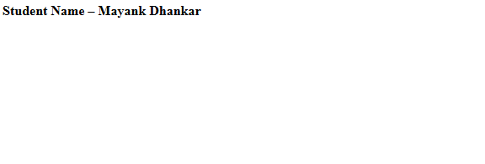Output-

Question 3) Create a web page and show the output from 1 to 10 in separate lines.

Input-

<html>

<head>

<title> Student Information </title>

</head>

<body>

<h4> Student Name – Mayank Dhankar </h4>

<p> 1 </p>

<p> 2 </p>

<p> 3 </p>

<p> 4 </p>

<p> 5 </p>

<p> 6 </p>

<p> 7 </p>

<p> 8 </p>

<p> 9 </p>

<p> 10 </p>

</body>

</html>

Output –

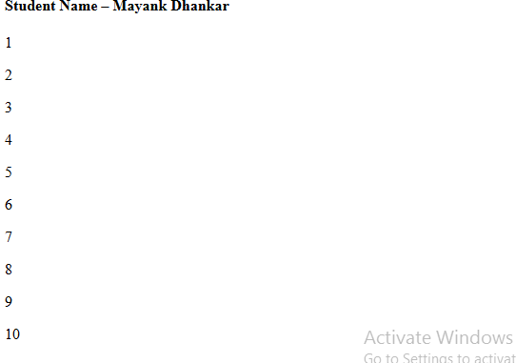

Question 4) Create a web page and show the output from 1 to 10 in separate lines, each number being in different color.

Input-

<html>

<head>

<title> Student Information </title>

</head>

<body>

<h4> Student Name – Mayank Dhankar </h4>

<p style="color: red;"> 1 </p>

<p style="color: purple;"> 2 </p>

<p style="color: orange;"> 3 </p>

<p style="color: pink;"> 4 </p>

<p style="color: green;"> 5 </p>

<p style="color: blue;"> 6 </p>

<p style="color: brown;"> 7 </p>

<p style="color: yellow;"> 8 </p>

<p style="color: violet;"> 9 </p>

<p style="color: black;"> 10 </p>

</body>

</html>

Output -



Question 5) How do I make a picture as a background on my web pages ?

Input-

<html>

<head>

<title> Student Information </title>

</head>

<body style="background-color: powderblue;">

<h3 style="color: Tomato;"> Adding picture to background </h3>

<img src="https://www.google.com/imgres?q=pablo%20escobar&imgurl=https%3A%2F%2Fwww.theperspective.se%2Fwp-content%2Fuploads%2F2023%2F12%2FEscobar-1024x723.png&imgrefurl=https%3A%2F%2Fwww.theperspective.se%2F2023%2F12%2F08%2Funcategorized%2F30-years-after-his-death-pablo-escobars-legacy-lives-on%2F&docid=s8fuyMfF6wBwyM&tbnid=WHWSp4L2kMLZ5M&vet=12ahUKEwi31q2AuKeJAxXVVWwGHcg3JC0QM3oECG4QAA..i&w=1024&h=723&hcb=2&ved=2ahUKEwi31q2AuKeJAxXVVWwGHcg3JC0QM3oECG4QAA ">

</body>

</html>

Output-

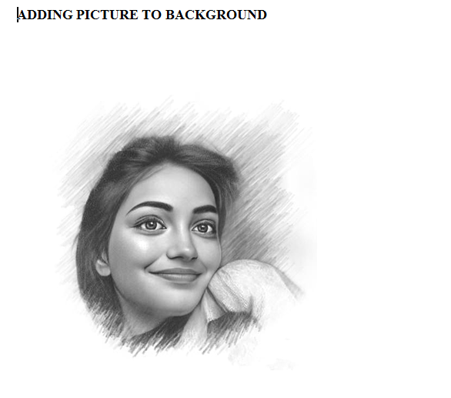

Question 6) Create a web page to print a paragraph with 4-5 sentences , each sentences shall have a different font.

Input-

<html>

<head>

<title> Student Information </title>

</head>

<body style="background-color: powderblue;">

<h5 style="Font-Family: Cursive;"> This is Paragraph one </h5>

<h4 style="Font-Family: Fantasy;"> This is Paragraph two </h4>

<h3 style="Font-Family: Helvetica;"> This is Paragraph three </h3>

<h2 style="Font-Family: Courier New;"> This is Paragraph four </h2>

<h1 style="Font-Family: Verdana New;"> This is Paragraph five</h1>

</body>

</html>

Output –

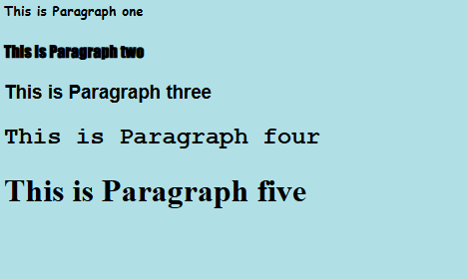

Question 7) Write HTML code to print a paragraph that is description of a book, it shall include the title of the book ,its author name and title should be underlined and all adjectives shall be bold and Italics.

Input-<html>

<head>

<title> Student Information </title>

</head>

<body style="background-color: powderblue;">

<p>Book name - <b><u><i> Harry Potter and the Philosopher's Stone</b></u></i> Author

name - <b><u><i>J. K. Rowling</b></u></i></p>

</body>

</html>

Output –

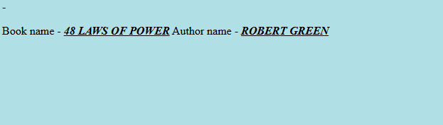

Question 8) Write HTML code to print your name using Heading tag, every letter shall be of different heading size.

Input-

<html>

<head>

<title> Heading Tag </title>

</head>

<body style="background-color:powderblue;">

<h1>D</h1>

<h2>E</h2>

<h3>E</h3>

<h4>P</h4>

<h5>A</h5>

<h6>K</h6>

</body>

</html>

Output –



Question 9) Write HTML code to print the sequence of number 1-20.Each number shall be in different line with number 2 next to it as subscript , an equal sign and the result.

Input-

<html>

<head>

<title> Heading Tag </title>

</head>

<body style="background-color:powderblue;">

<p>1<sub>2</sub> = 2</p>

<p>2<sub>2</sub> = 4</p>

<p>3<sub>2</sub> = 6</p>

<p>4<sub>2</sub> = 8</p>

<p>5<sub>2</sub> = 10</p>

<p>6<sub>2</sub> = 12</p>

<p>7<sub>2</sub> = 14</p>

<p>8<sub>2</sub> = 16</p>

<p>9<sub>2</sub> = 18</p>

<p>10<sub>2</sub> = 20</p>

<p>11<sub>2</sub> = 22</p>

<p>12<sub>2</sub> = 24</p>

<p>13<sub>2</sub> = 26</p>

<p>14<sub>2</sub> = 28</p>

<p>15<sub>2</sub> = 30</p>

<p>16<sub>2</sub> = 32</p>

<p>17<sub>2</sub> = 34</p>

<p>18<sub>2</sub> = 36</p>

<p>19<sub>2</sub> = 38</p>

<p>20<sub>2</sub> = 40</p>

</body>

</html>

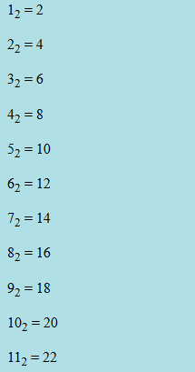Output

Ques 10) Write html code to display an image with border of size with width 200,height 200 pixels, leaving Hspace and Vspace of your choice with image hanging in the right side on the screen.

Input-

<HTML>

<head>

<title>Image Display</title>

<style>

img {

border: 2px solid black;

width: 200px;

height: 200px;

display: block;

margin-left: auto;

margin-right: 0;

margin-top: 20px;

margin-bottom: 20px; }

</style>

</head>

<body>

<img src="https://i.pinimg.com/originals/cb/21/2f/cb212f92878b0a5d511ed98f9ddbf1a8.jpg"Sample Image">

</body>

</html>

Output-

Ques 11) Write HTML code create a web page with heading . The heading shall be displayed at the top-center of the page and the image shall be at the center ,just below the heading.

Input--<html>

<head>

<title>Centered Heading and Image</title>

<style>

body {

margin: 0;

font-family: Arial, sans-serif;

text-align: center;

justify-content: center;

align-items: center;

</style>

</head>

<body>

<h1>DRUG LORD PABLO ESCOBAR</h1>

<img src="https://www.PPLOOa.gov.in/wp-content/uploads/2024/06/Know-the-PM-Thumbnail.jpg">

</body>

</html>

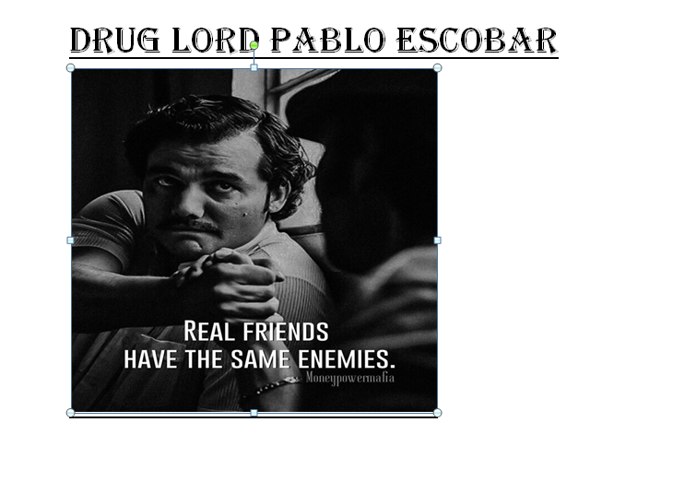Output-

Ques 13) Create a Table using Rowspan and Colspan taking example of student Record.

Input: <html>

<head></head>

<body>

<table border='4pt'>

<tr>

<th colspan='2'>Name</th>

<th>class</th>

<th>school</th></tr>

<tr>

<td rowspan='2'>pablo</td>

<td rowspan='2'>escobar</td>

<td> 11</td>

<td>mvps</td></tr>

<tr>

<td>A</td></tr>

<tr>

<td rowspan='2'>andrew</td>

<td rowspan='2'>tate</td>

<td> 3</td>

<td>nvps</td></tr>

<tr>

<td>B</td></tr>

<tr>

<tr>

<td rowspan='2'>chota</td>

<td rowspan='2'>bheem</td>

<td> J</td>

<td>avps</td></tr>

<tr>

<td>A</td></tr>

</table>

</body>

</html>

Output: 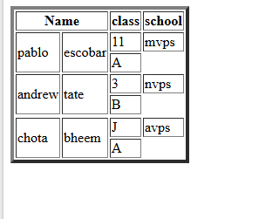



Q14.Write HTML code using table tag <table> and cellpadding and cell spacing as its attributes.

 Input:

<html>

<head></head>

<body>

<table border="2pt" cellspacing="5pt" cellpadding="5pt">

<tr>

<th>S.no</th>

<th>Roll no.</th>

<th>Name</th>

<th>Address</th></tr>

<tr>

<td>1</td>

<td>123</td>

<td>ABC</td>

<td>FBD</td></tr>

<tr>

<td>2</td>

<td>456</td>

<td>XYZ</td>

<td>delhi</td></tr>

<tr>

<td>3</td>

<td>789</td>

<td>PQR</td>

<td>gurgaon</td></tr>

</table>

</body>

</html>

Output-

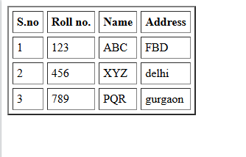

Q15. Create unordered, ordered and definition Lists taking example of your subjects in MCA IST, IInd and IIIrd Semester.

Input :

<html>

<head></head>

<body>

<h3> Subjects in BCA sem 1</h3>

<ol>

<li>Web technologies</li>

<ul>

<li>introduction to Networks</li>

<li>introduction to e-mail</li>

<li>introduction to html</li>

</ul>

<li>Introduction to IT & programming in C</li>

<ul>

<li>Input output devices</li>

<li>compilers,Interpreters,assemblers</li>

<li>various programs in C</li>

</ul>

<li>Mathematics</li>

<ul>

<li>matrices</li>

<li>surds and insurdes</li>

<li>trigonometry</li><ul><ol>

</body>

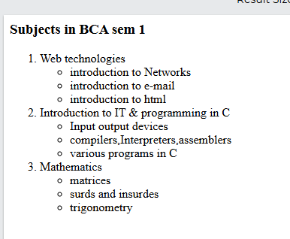</html>

Output-

Q 17)Write HTML code to design a form in html using controls and buttons such as textbox,textarea , password, submit button, browse button, drop-down menu.

Input-

<html>

<body>

<fieldset><legend><font color='Blue'>APPLICATION FORM</font></legend></feildset>

<form><bgcolor='red'>

<label>First Name:</label>

<input type='text'name='name' id='name'>

<label>Last Name:</label>

<input type='text' name='name' id='name'><br><br>

<label>Date Of Birth:</label>

<input type='date'><br><br>

<label>Gender:</label>

<input type='radio' name='gender' value='Male' >

<label>Male</label>

<input type='radio' name='gender' value='Female' >

<label>Female</label><br><br>

<label>Contact No:</label>

<input type='textbox'><br><br>

<label>Email Address:</label>

<input type='email' placeholder='Enter email address'><br><br>

<label>Position Available</label><br>

<input type='checkbox' value='Assistant HR'>

<label>Assistant HR</label><br>

<input type='checkbox' value='Junior developer'>

<label>Junior developer</label><br>

<input type='checkbox' value='Senior developer'>

<label>Senior developer</label><br>

<input type='checkbox' value='Web designer'>

<label>Web designer</label><br><br>

<label>Any other Information:</label><br>

<textarea rows='4' cols='20'>Enter your full info</textarea>

<br><br>

<input type='submit' value='Submit'>

<input type='reset' value='Reset'>

</form>

</body>

</html > Output-